**Day 16 Assignment - Vamsi Viswanadham**

**Date: 21/12/2023**

**Apache Spark**

Apache Spark is an open-source, distributed computing system that offers an easy-to-use and fast solution for handling big data. It's designed to efficiently process large-scale data workloads by distributing computation across multiple computers. Here are some key features of Apache Spark:

* Speed and Efficiency: Spark is known for its speed in batch processing, and it's also capable of stream processing. It excels in iterative computation, which makes it faster than traditional big data technologies like Hadoop MapReduce.
* Ease of Use: Spark supports multiple programming languages like Scala, Java, Python, and R, making it accessible to a broad range of developers. It comes with built-in modules for SQL, streaming, machine learning, and graph processing.
* Flexibility: It can run in a variety of environments including on-premises, in the cloud, and with various data storage systems.
* Advanced Analytics: Spark not only supports 'map' and 'reduce' operations, but it also supports SQL queries, streaming data, machine learning, and graph data processing.

**Setting Up Apache Spark on Windows**

To set up Apache Spark on a Windows system, follow these steps:

Step 1: Install Java

Spark requires Java 8 or later. Download and install the Java Development Kit (JDK) from Oracle's website or use an OpenJDK version.

Set the JAVA_HOME environment variable to your JDK installation path.

Step 2: Install Python (Optional)

If you plan to use PySpark (the Python API for Spark), ensure Python is installed on your system.

Set the PYTHONPATH environment variable if necessary.

Step 3: Download and Install Apache Spark

Visit the Apache Spark website and download the latest version of Spark.

Unzip the Spark files to a directory on your computer, such as C:\spark.

Step 4: Set Environment Variables

Set the SPARK_HOME environment variable to your Spark installation directory (e.g., C:\spark).

Add %SPARK_HOME%\bin to your system's Path environment variable.

Step 5: Install Hadoop Winutils (Optional but Recommended)

Spark on Windows requires Hadoop's winutils binary. Download it and place it in a directory like C:\hadoop\bin.

Set the HADOOP_HOME environment variable to your Hadoop bin directory (e.g., C:\hadoop).

Step 6: Testing the Installation

Open a command prompt and type spark-shell. This should open the Spark Scala shell.

To test PySpark, type pyspark in the command prompt.

Step 7: Using Spark

You can now start developing Spark applications using Scala, Python, or Java.

Explore Spark's documentation for more detailed information on using Spark, including its core API and its data processing capabilities.

Here is the output of the Installation:

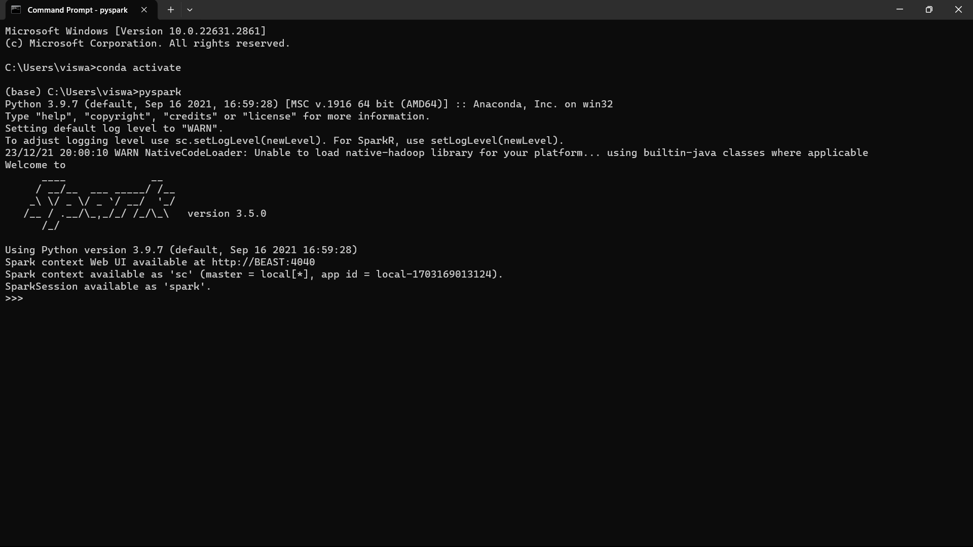

Here is the Spark GUI Interface of the work:

